Student Alert

Test Document

**User Registration** **7**

**Reset Password** **9**

**Login** **11**

**Logout** **13**

**Dashboard** **14**

**Edit Availability** **15**

**Add Assignment** **18**

**Edit Assignment** **20**

**Delete Assignment** **22**

**Notification** **24**

**Overdue Notifications** **27**

**View/Edit Account** **28**

**Admin User Feature** **30**

**Testing Completion Approval** **34**

|  |  |  |  |
| --- | --- | --- | --- |
| Step | Description | Exception Handling | Fields |
| User Registration | Step 1: Open the application.  Step 2: The user clicks on the"user registration" menu item.  Step 3: The user provides the relevant fields to register in the system  Step 4: The application will notify the user upon successful registration, if the same email is not found in the system and mandatory fields are provided. | Exception #1: Users will be notified if there is another user with the same email in the system.  Exception #2: All mandatory fields are not provided. | First Name, Last Name, E-Mail, Password, Confirm-Password, DOB, etc.. |
| Reset Password | Step 1: Open the application.  Step 2: The user clicks on the "Reset Password" menu item.  Step 3: The system will allow the user to provide the email address used to register the user.  Step 4: The system will send a temporary password to the email address provided, if the user exists in the system. | Users will be notified if the user email doesn't exist in the system. | E-Mail |
| Login | Step 1: Open the application.  Step 2: The user clicks on the "Login" menu item.  Step 3: The user will be prompted to provide their email address and password.  Step 4: User will login into the application and be redirected to the dashboard, if the credentials provided are valid | Users will be notified if the user credentials are wrong. | E-Mail, Password |
| Logout | Step 1: The user clicks on the "Logout" menu item, if the user is already logged in.  Step 2: The user will be redirected to the login page upon successful logout. | NA | NA |
| Dashboard | Step 1: Open the Application.  Step 2: Login to the system with valid credentials.  Step 3: The user will be usually redirected to the dashboard (i.e. default page) upon successful login to the application or the user can click on the "Dashboard" menu item to view the default page.  Step 4: The user can enter their availability times by day.  Step 5: The dashboard displays the list of assignments with respective each assignment details, such as assignment name, start day/time, end day/time, description, etc. | No existing schedules to load | NA |
| Edit Availability | Step 1: Open the Application  Step 2: Login to the system with valid credentials.  Step 3: From the dashboard, the user will then be able to click on the "Edit Availability" menu item.  Step 4: The user will be able to enter availability for each day of the week in time. | Exception #1: Start time must be before end time | Day of Week, Availability Start Time, Availability End Time |
| Add Assignment | Step 1: Open the Application.  Step 2: Login to the system with valid credentials.  Step 3: The user clicks on the "Add Assignment" menu item.  Step 4: The application will prompt the user to add the assignment with its respective details.  Step 5: Once the assignment is added, it will have a status of "Open". | Exception #2: All mandatory fields are not provided | Assignment Name, Anticipated Time to Complete, Description, Choose Label Color, Status (i.e. Open, In Progress, Completed, Cancelled), Priority |
| Edit Assignment | Step 1: Open the Application.  Step 2: Login to the system with valid credentials.  Step 3: From the dashboard, the user will be able to select a particular day from the calendar, and the application displays the list of assignments for that particular day in a list view.  Step 4: The user can double click on a particular assignment from the list, and the assignment detail is shown in a popup window.  Step 5. The user will be able to make the needed adjustment and click the "Update" button. | Exception #1: If there is no available spot on the particular date to fit this assignment.  Exception #2: All mandatory fields are not provided. | Assignment Name, Anticipated Time to Complete, Description, Choose Label Color, Status (i.e. Open, In Progress, Completed, Cancelled), Priority |
| Delete Assignment | Step 1: Open the Application.  Step 2: Login to the system with valid credentials.  Step 3: From the dashboard, the user will be able to select a particular date from the calendar, and the application displays the list of assignments for that particular date in a list view.  Step 4: The user will be able to select a particular assignment from the list, and click the "Delete" button. The user will be prompted with a confirmation window prior to a successful deletion. | NA | NA |
| Notification | Step 1: Open the Application.  Step 2: Login to the system with valid credentials.  Step 3: The system will automatically notify the user 1 hour, 30 minutes,15 minutes & 5 minutes before the start of a particular assignment/task. Once the assignment time is 0 minute, the status of the assignment will change automatically to "In Progress". | NA | NA |
| Overdue Assignments | Step 1: Open the Application.  Step 2: Login to the system with valid credentials.  Step 3: The user clicks on the "Overdue Assignments" menu item.  Step 4: The system will display all the overdue assignments in a list. The user can double click on the assignment, and view the detail of the assignment in a pop-up window and edit the detail from the same window. | Exception #1: If there is no available spot on the particular date to fit this assignment.  Exception #2: All mandatory fields are not provided. | Assignment Name, Start Time & Date, End Time & Date, Anticipated Time to Complete, Description, Choose Label Color, Status (i.e. Open, In Progress, Completed, Cancelled), etc. |
| View/Edit Account | Step 1: Open the Application.  Step 2: Login to the system with valid credentials.  Step 3: The user clicks on the "View/Edit Account" menu item.  Step 4: The system will show the user detail in a pop-up window, allowing the user to update their details. | Exception #1: Users will be notified if another user with the same email exists in the system when editing details.  Exception #2: All mandatory fields are not provided when editing. | First Name, Last Name, E-Mail, Password, Confirm-Password, DOB, Notes. etc. |
| Admin User Feature | Step 1: Open the Application.  Step 2: Login to the system with valid admin credentials. The system by default will have one admin user configured initially.  Step 3: The system will display the users in a list, enabling the Admin user to delete and edit users delete. | Exception #1: Admin users will be notified if another user with the same email exists in the system when editing details.  Exception #2: All mandatory fields are not provided when editing. | First Name, Last Name, E-Mail, Password, Confirm-Password, DOB, Notes, etc.. |

# 

# User Registration

1. Opened the application.
2. Clicked File, User Registration.
3. Clicked Register User without filling in any fields.
4. Received error message below as expected.

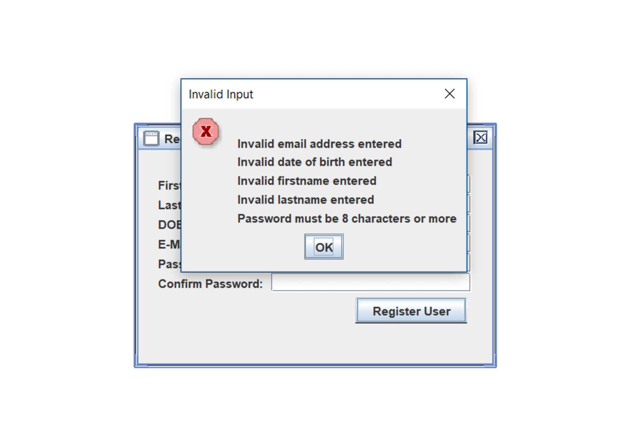

Figure 1: Invalid input exception message

1. Entered firstname, lastname, email, date of birth, and password. Enter a confirm password that doesn’t match. Received error message below as expected.

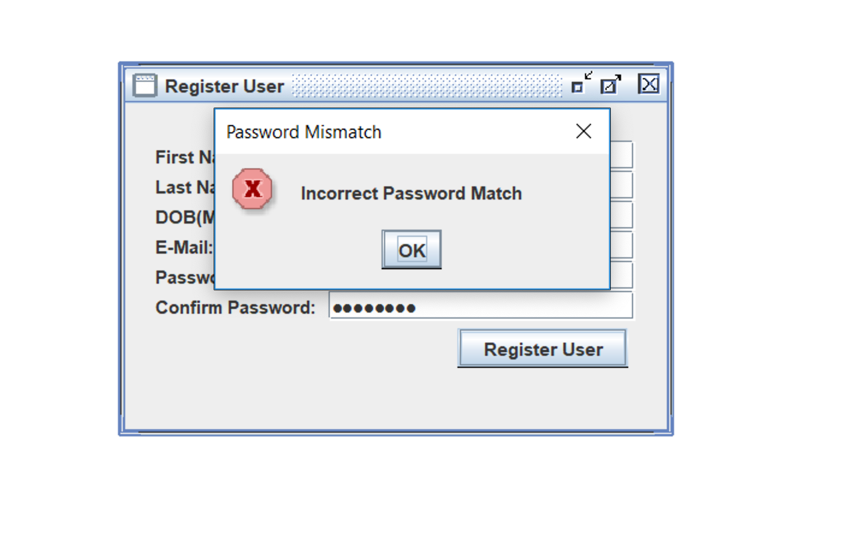

Figure 2: Password mismatch error message

1. Entered values again using all correct information.

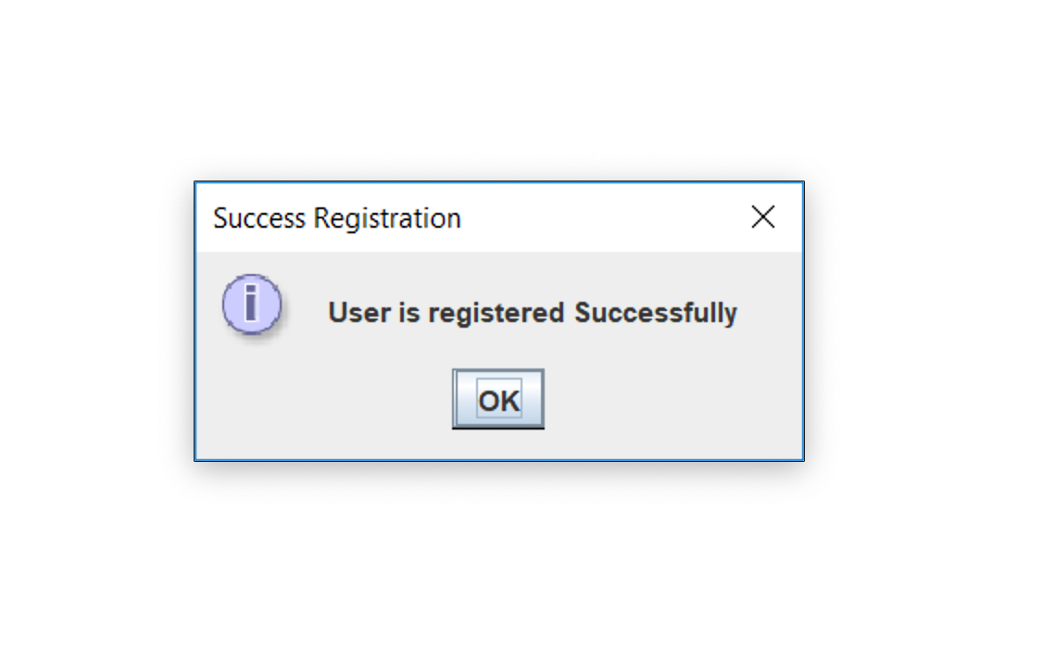

Figure 3: Successful registration message

Upon successful registration, it was verified that the profile was created along with all of the necessary default files and content.

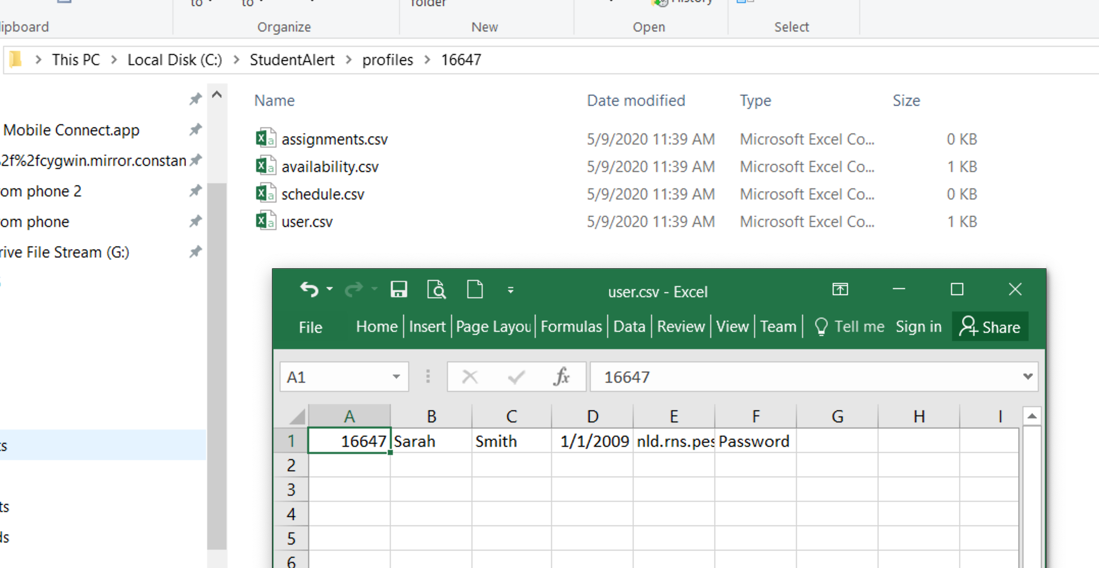

Figure 4: Profile creation

# Reset Password

1. Opened the application.
2. Selected FIle, Reset Password.
3. Entered an invalid email address.
4. Received error message below as expected.

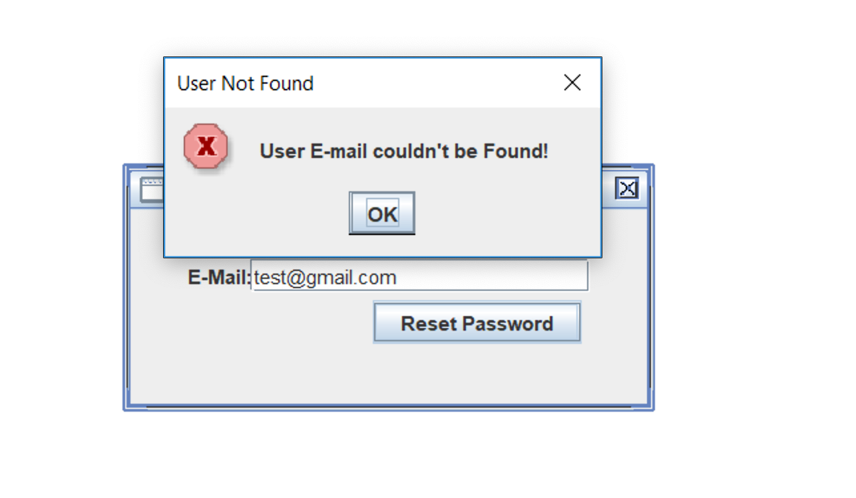

Figure 5: Email not found error message

1. Entered valid email and received message below along with email.

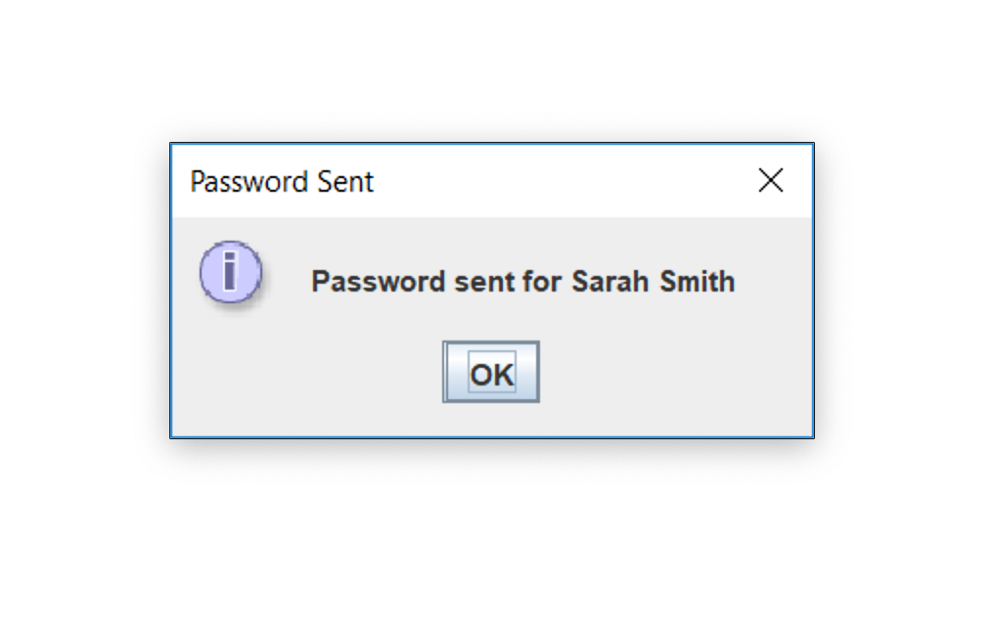

Figure 6: Password reset message

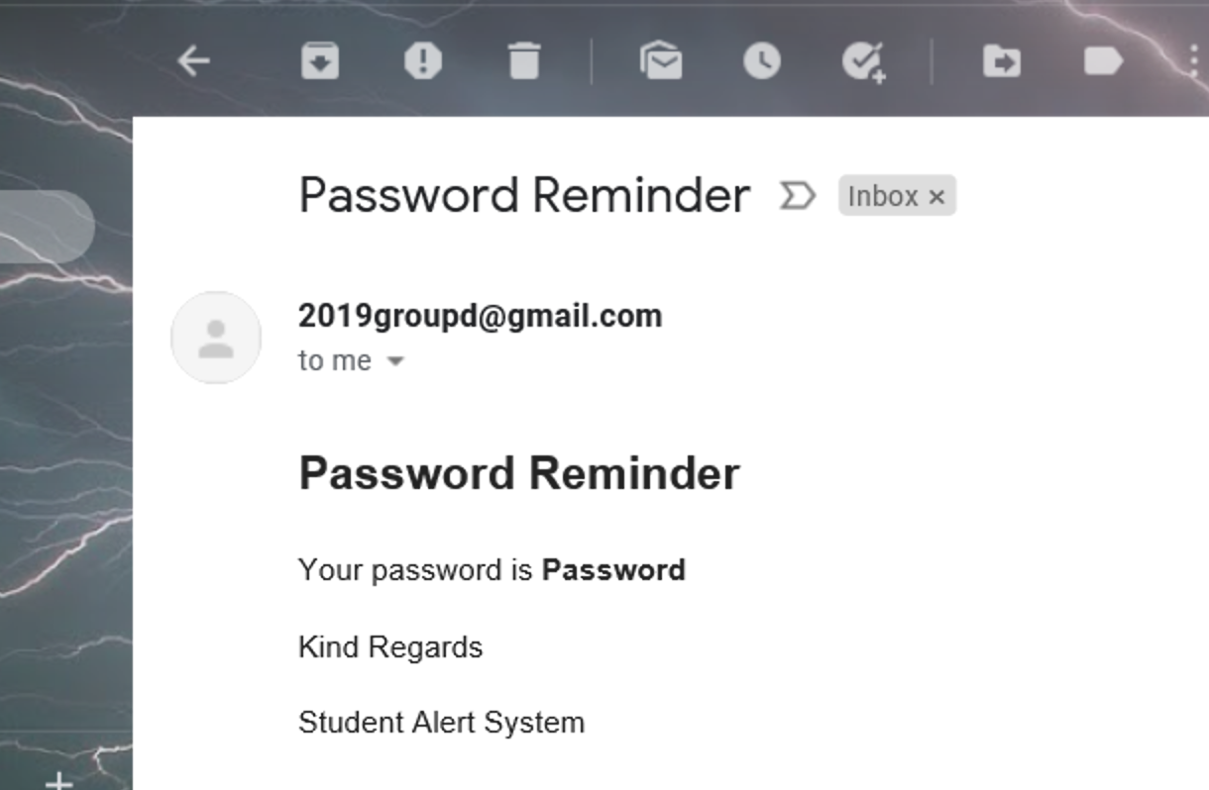

Figure 7: Password reset email

# Login

1. Opened the application.
2. Selected File, Login.
3. Entered an inavlid username and password and received the message below.

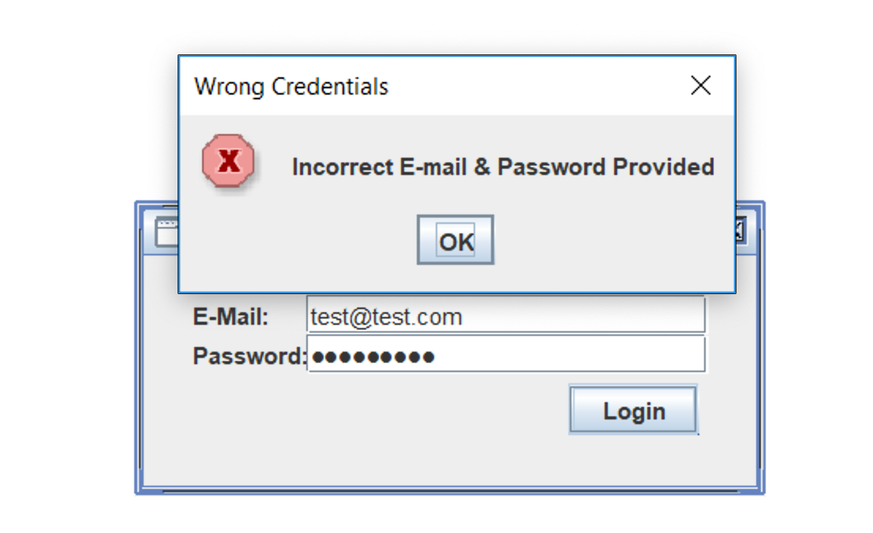

Figure 8: Invalid user error message

1. Entered a valid username with an incorrect password and received the error message below.

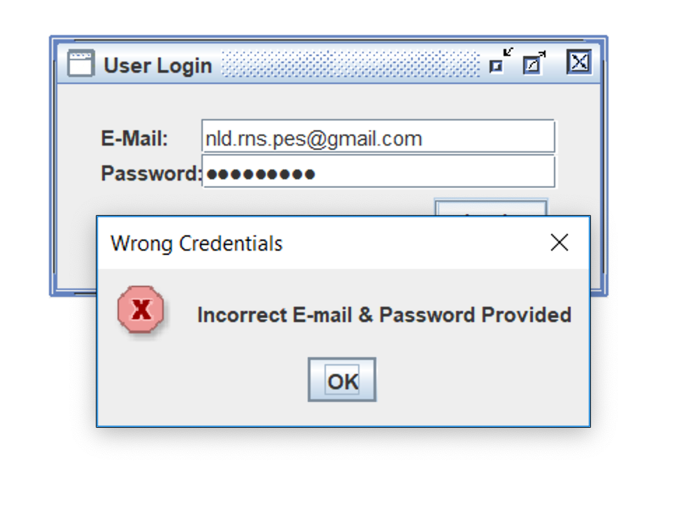

Figure 9: Error message for incorrect password

1. Entered correct username and password and all menu options appear.

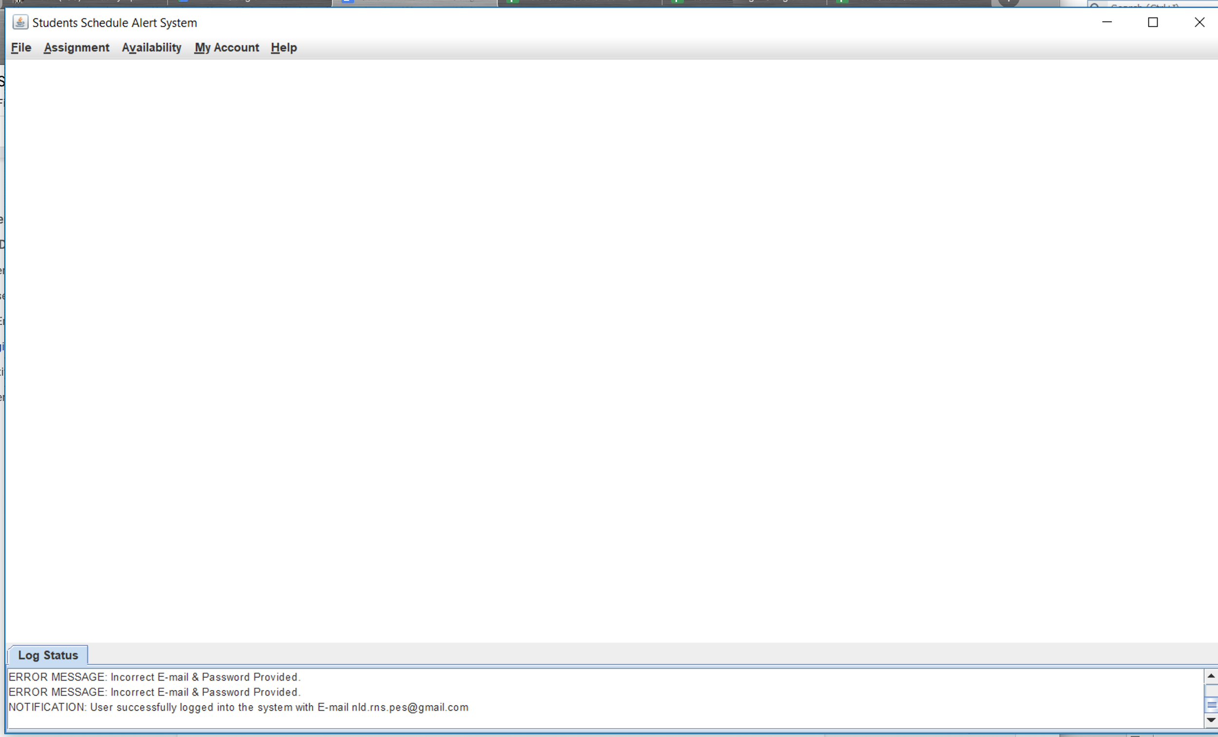

Figure 10: Successful log in

# Logout

1. After successfully logging in to the application, selected File, Logout.

Menu options disappear as shown below and the user is logged out.

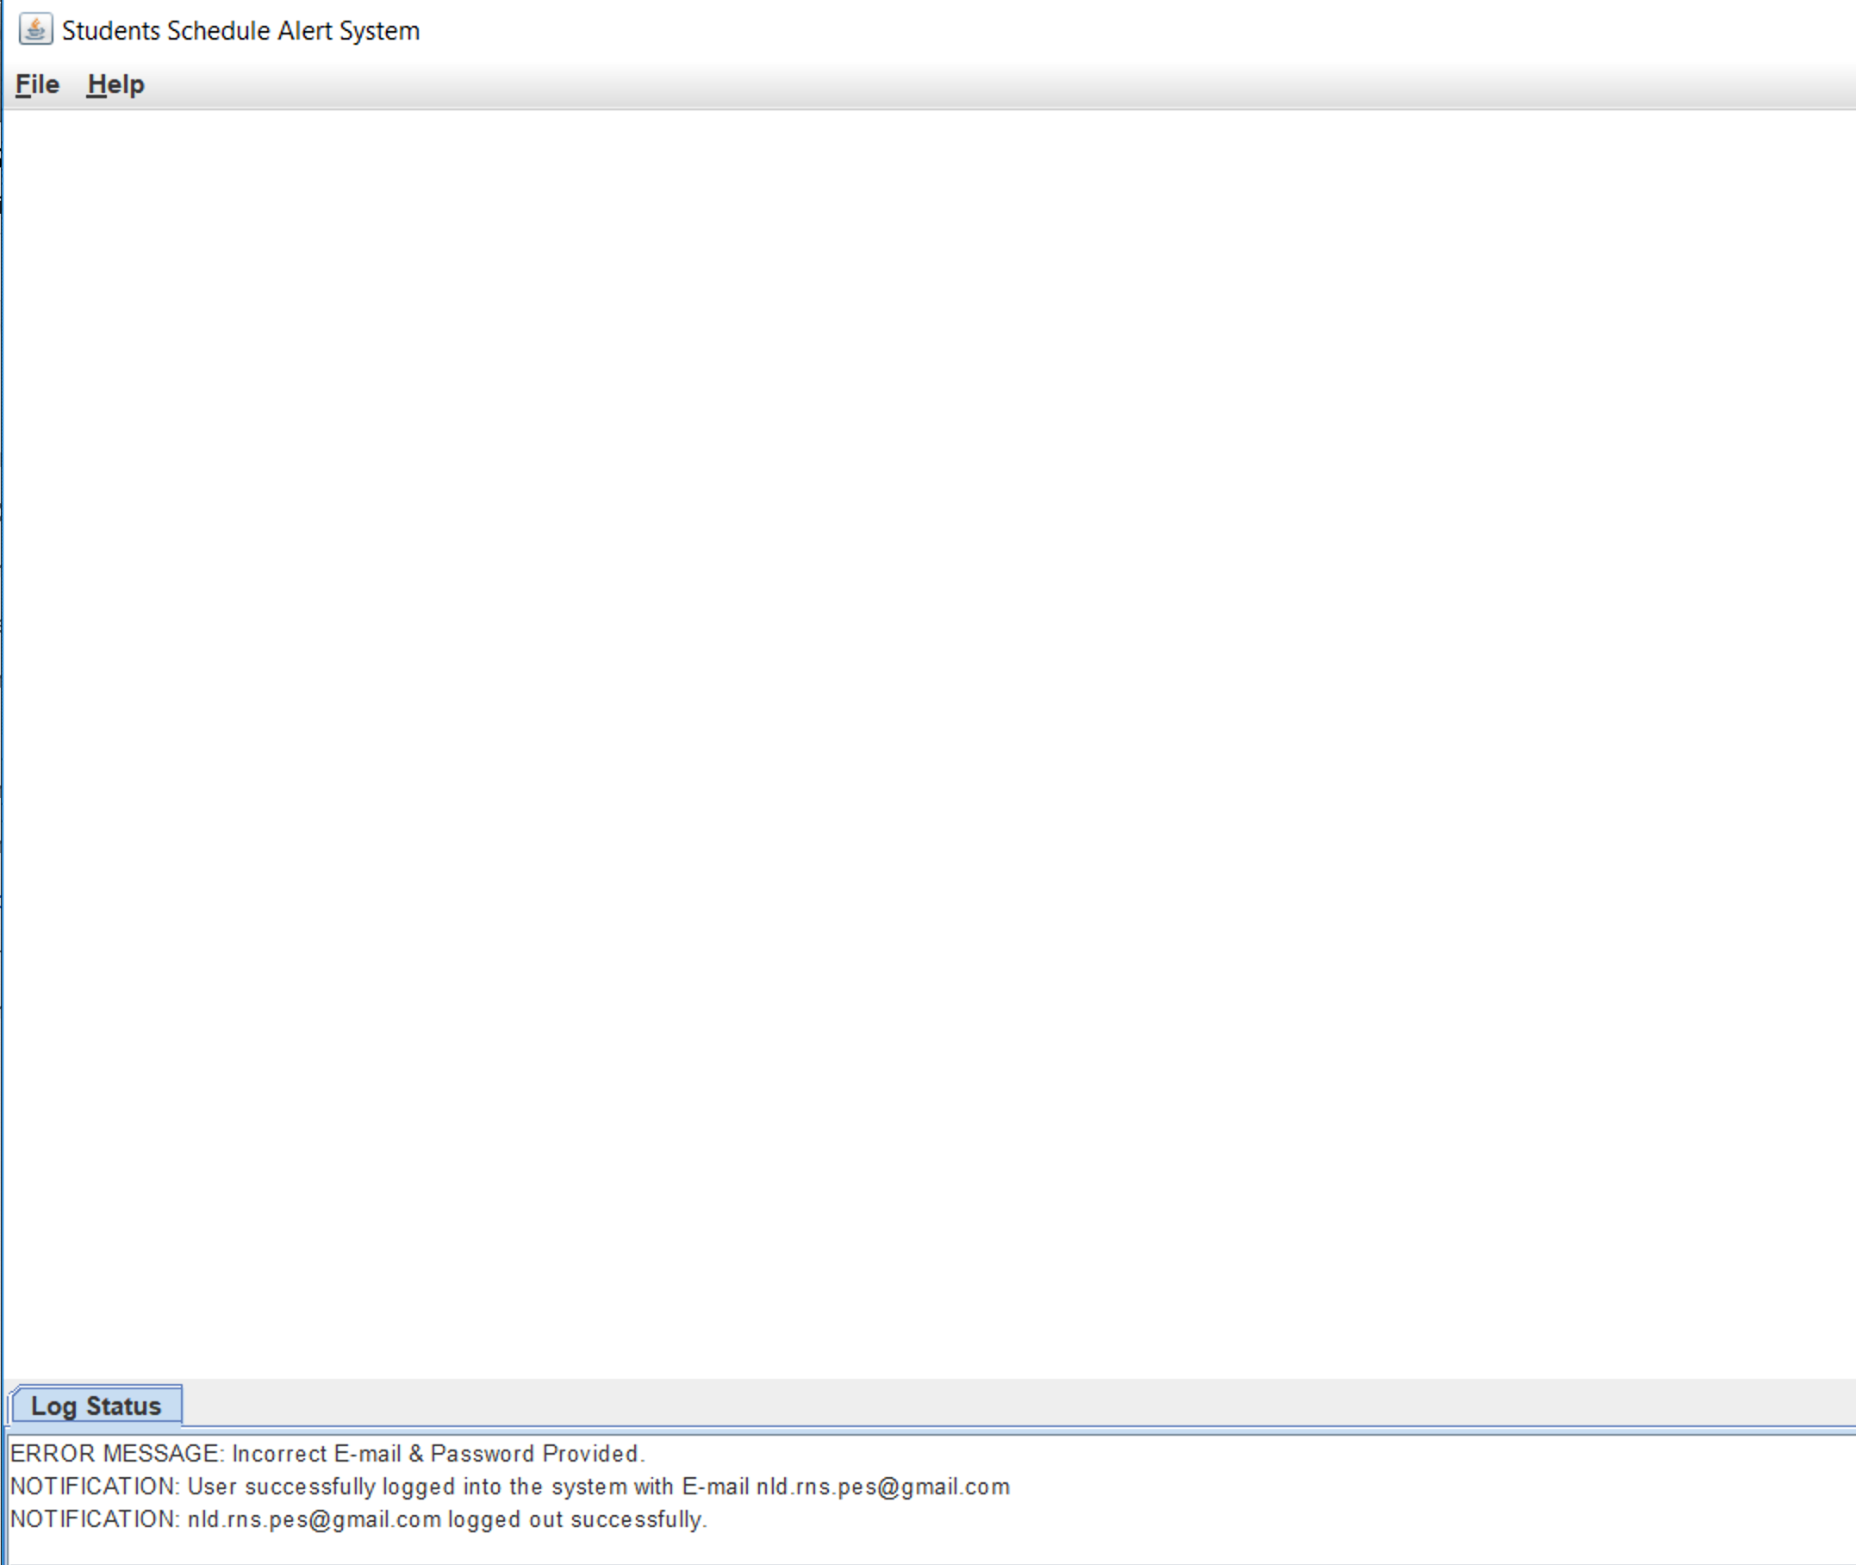

Figure 11: Successful Logout

# Dashboard

Upon successful login, select File, Dashboard. Currently, no assignments have been added, so the Dashboard simply appears empty.

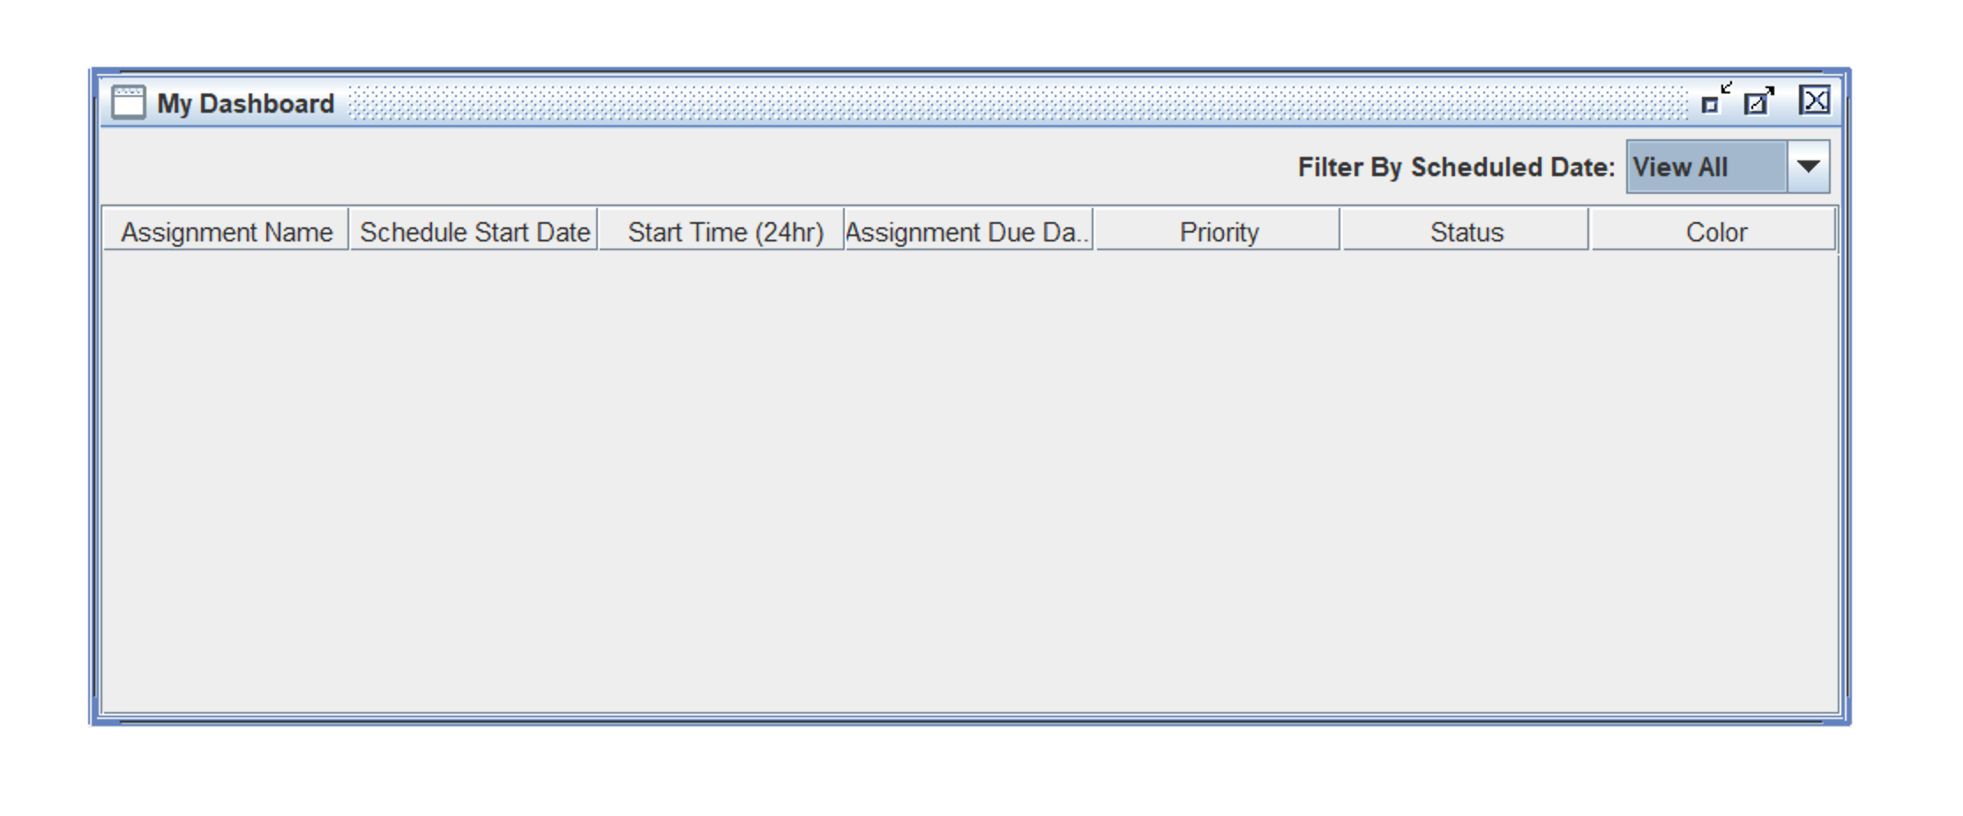

Figure 12: Empty dashboard

After assignments have been added, the Dashboard now displays the schedule and the assignments as below.

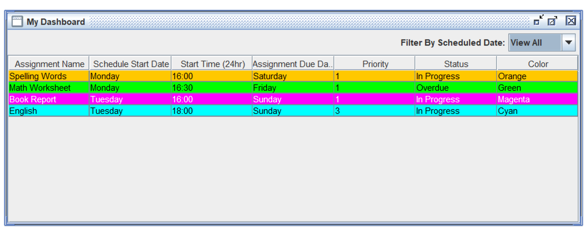

Figure 13: Dashboard after assignments have been added.

# Edit Availability

1. After successfully logging in for the first time, selected Availability, Edit Availability. The default availability displays.

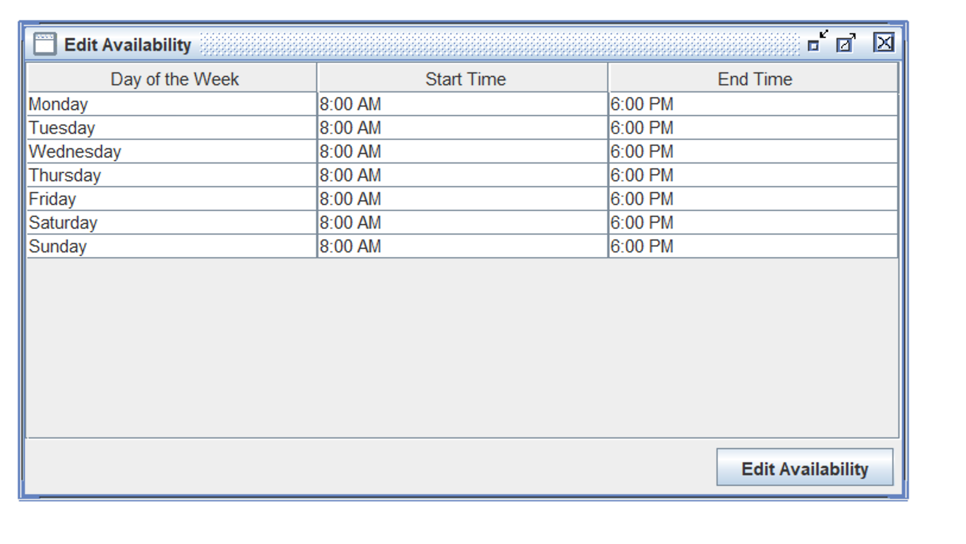

Figure 14: Default availability

1. Entered an invalid value in the time field for Monday and received the message below.

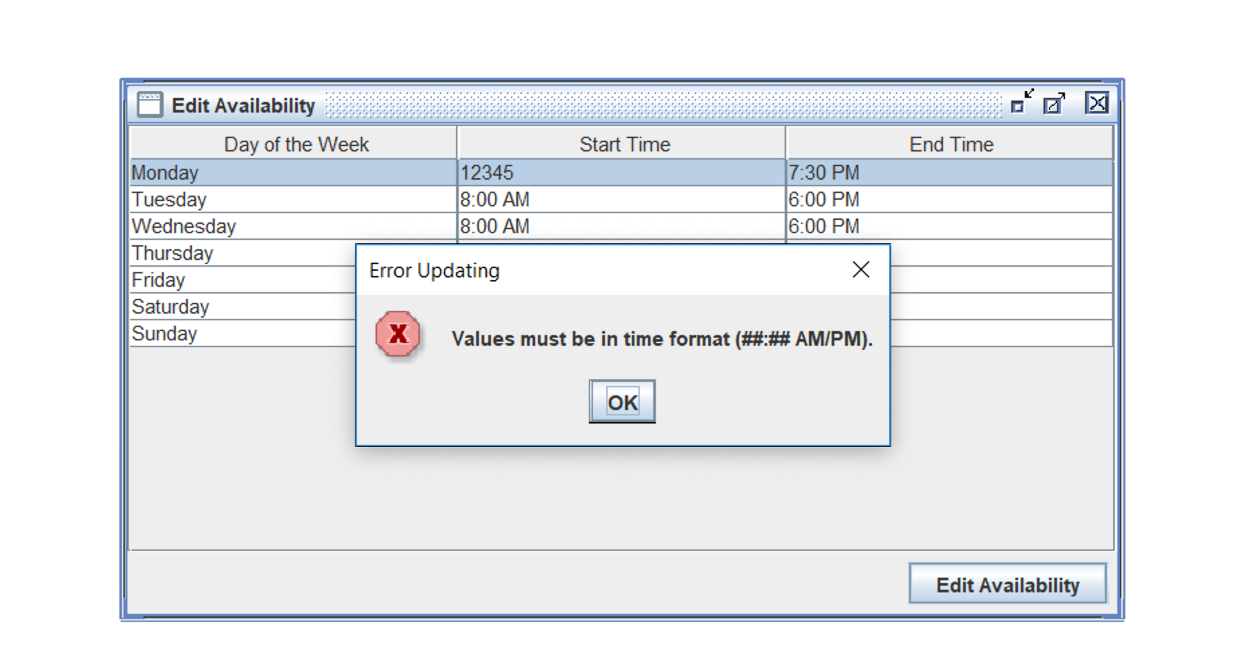

Figure 15: Invalid input error message

1. Modified the availability to be 4:00 PM to 7:30 PM Monday through Friday. Left Saturday and Sunday as is.

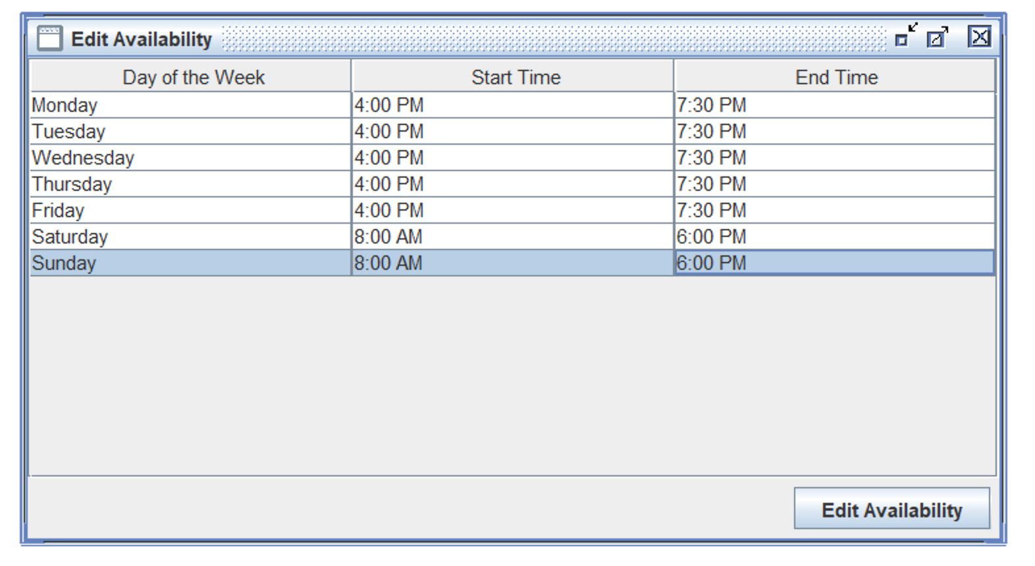

Figure 16: Modifying availability

1. Clicked the Edit Availability button and received a success message.

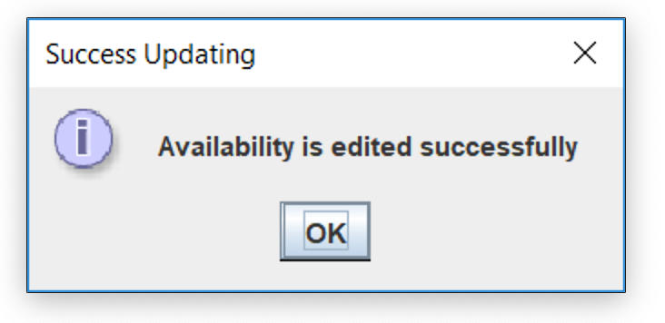

Figure 17: Success message for modifying availability

The availability file has been modified accordingly as seen below.

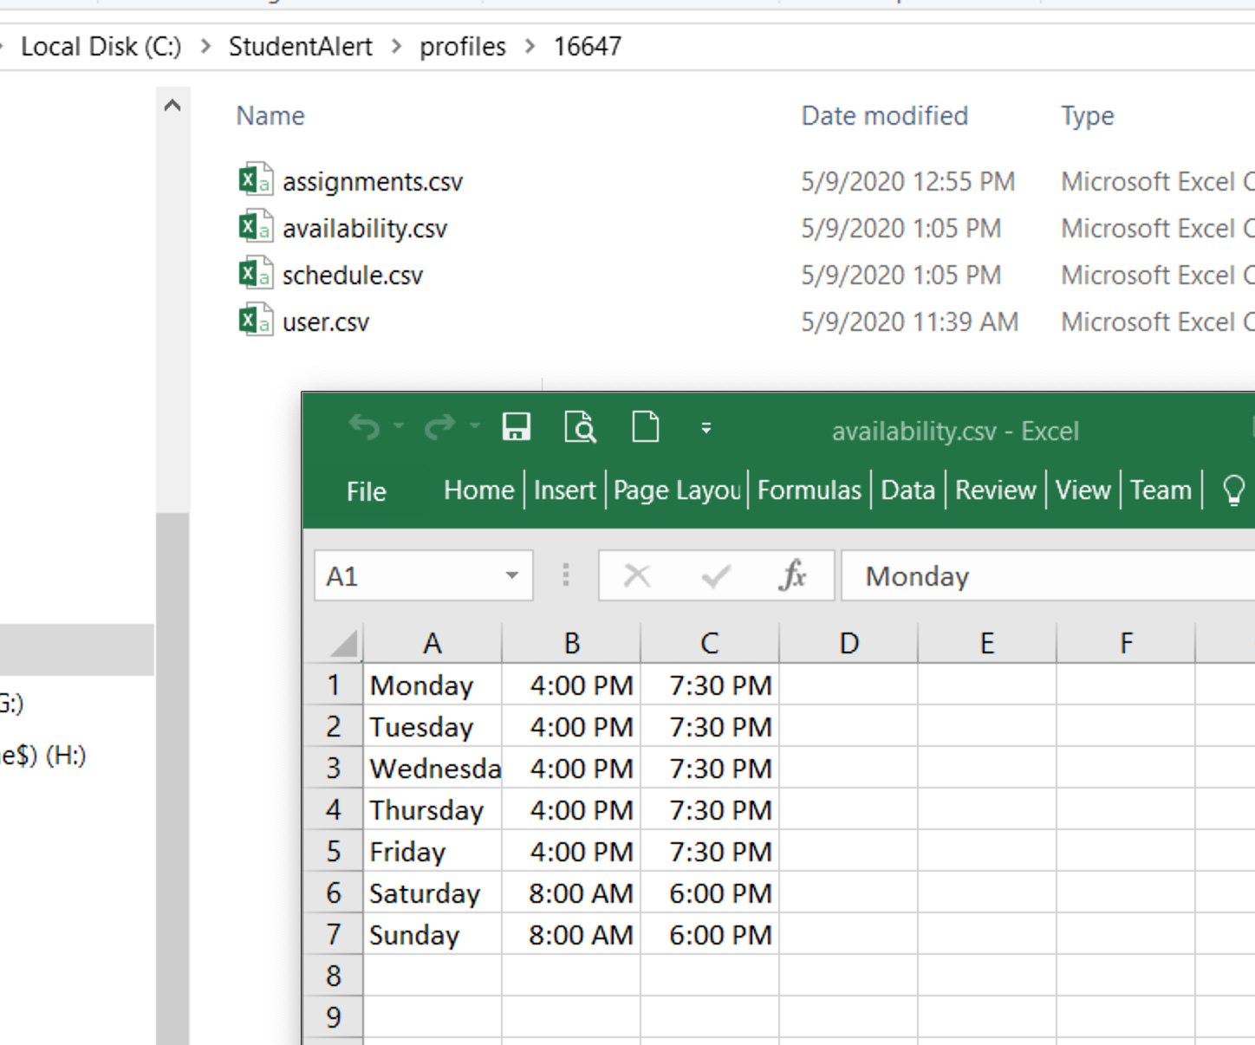

Figure 18: File successfully modified after availability modifications

# Add Assignment

1. After successfully logging in, selected Assignment, Add Assignment.
2. Clicked the Add Assignment button without entering any values and received the message below.

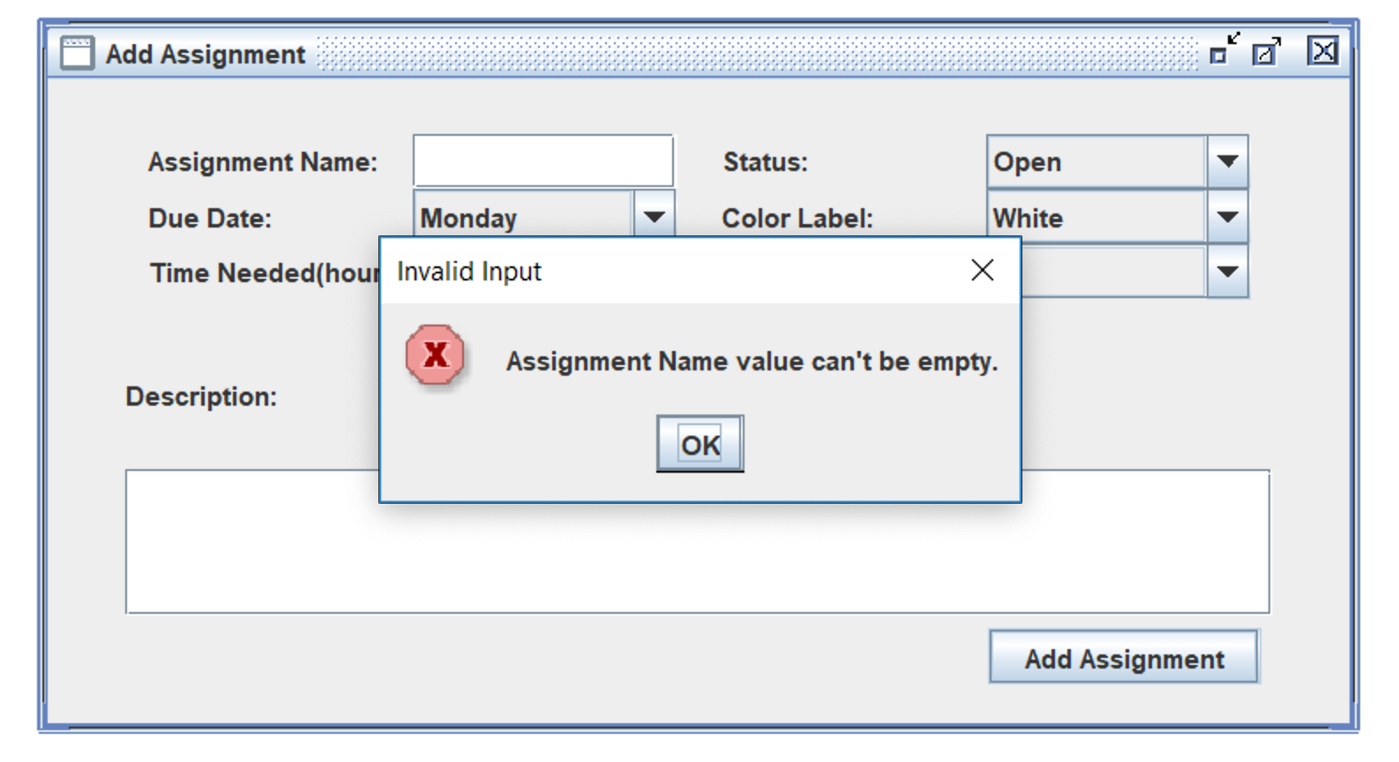

Figure 19: Invalid input on add assignment screen

1. Entered valid assignment information as seen below.

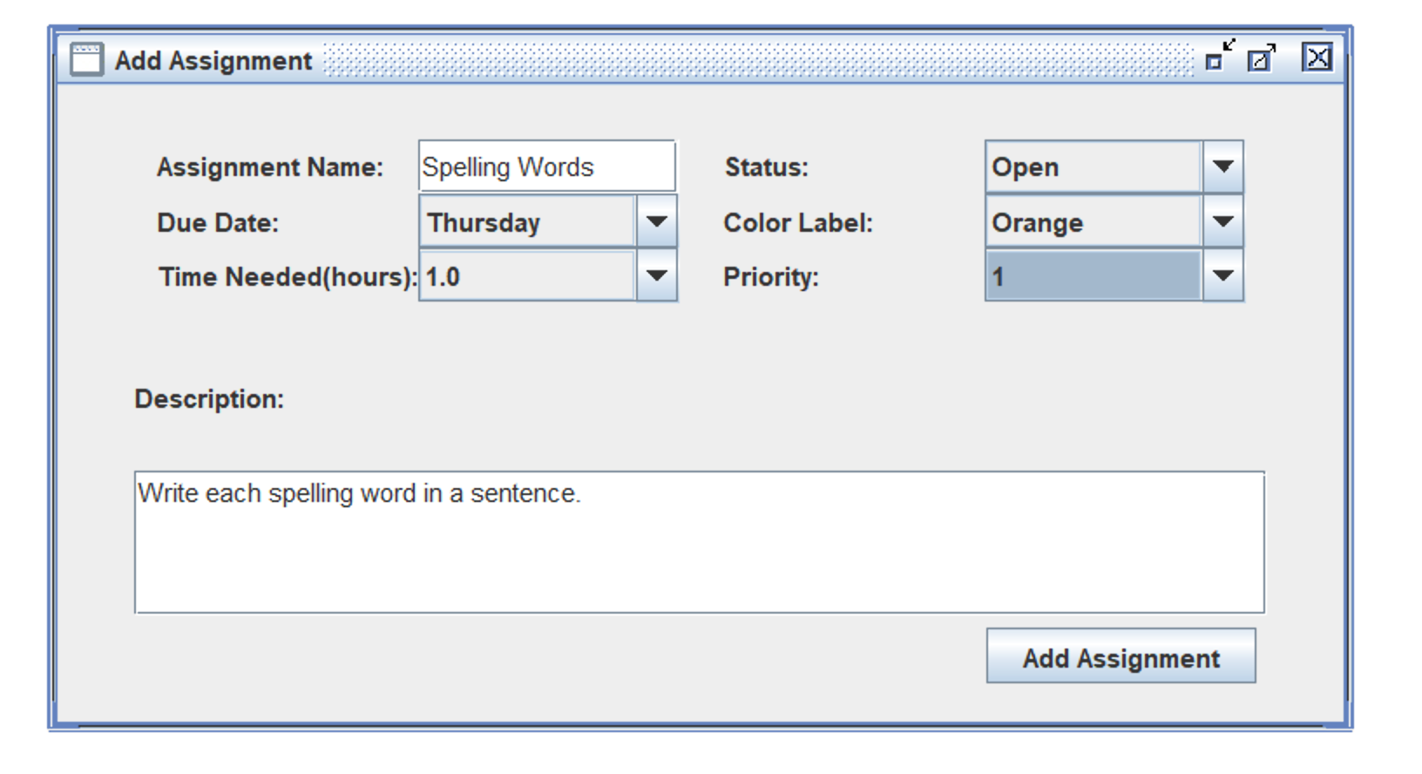

Figure 20: Assignment details

1. Clicked the Add Assignment button and received the message below.

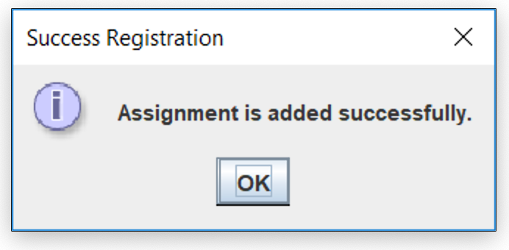

Figure 21: Assignment added successfully.

The assignment file has been updated as desired.

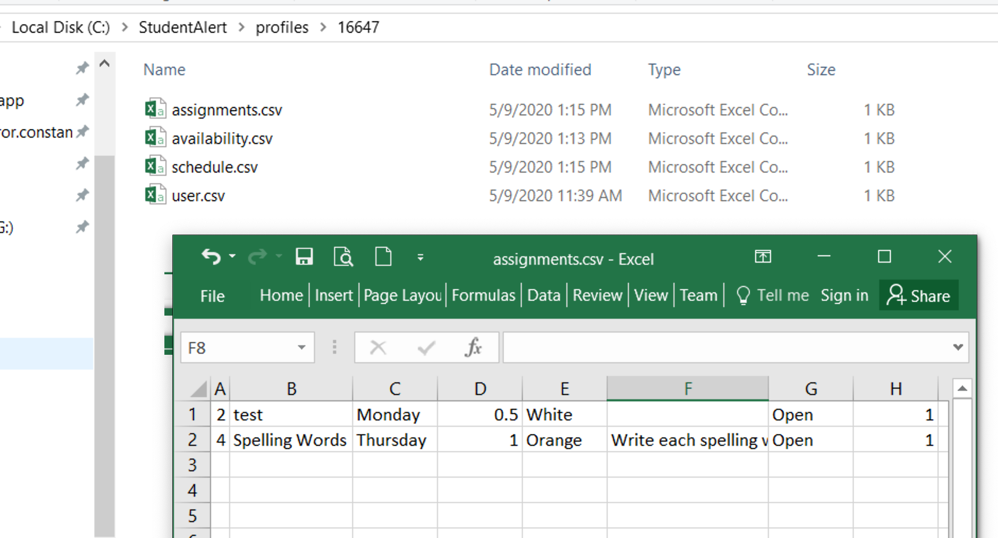

Figure 22: Assignment file

# Edit Assignment

1. After successfully logging in and adding assignments, selected Assignments, Edit Assignments menu option. Modified the amount of time needed to complete the assignment from 1 hours to 0.5 hour and the due date to Wednesday.

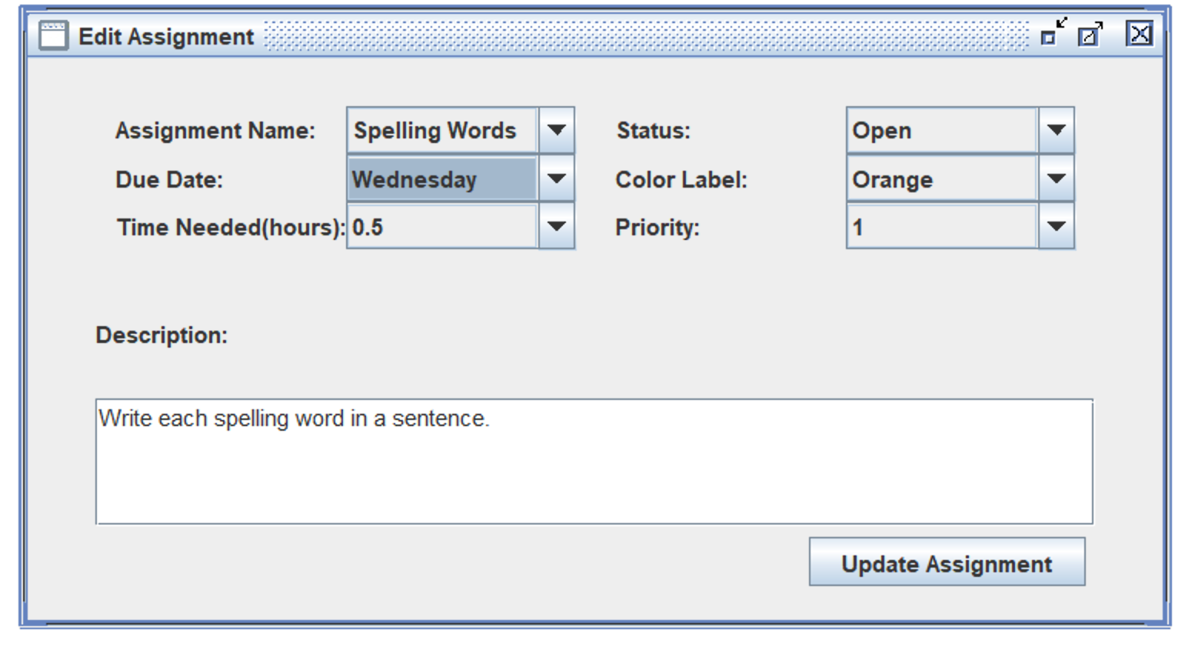

Figure 23: Modifying assignment

1. Clicked the Update Assignment button and received a success message.

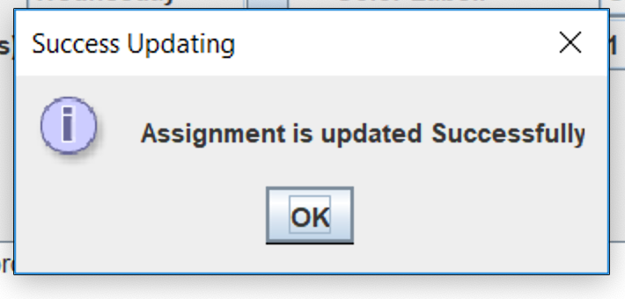

Figure 24: Successful edit of assignment

1. The assignment file has been modified as desired.

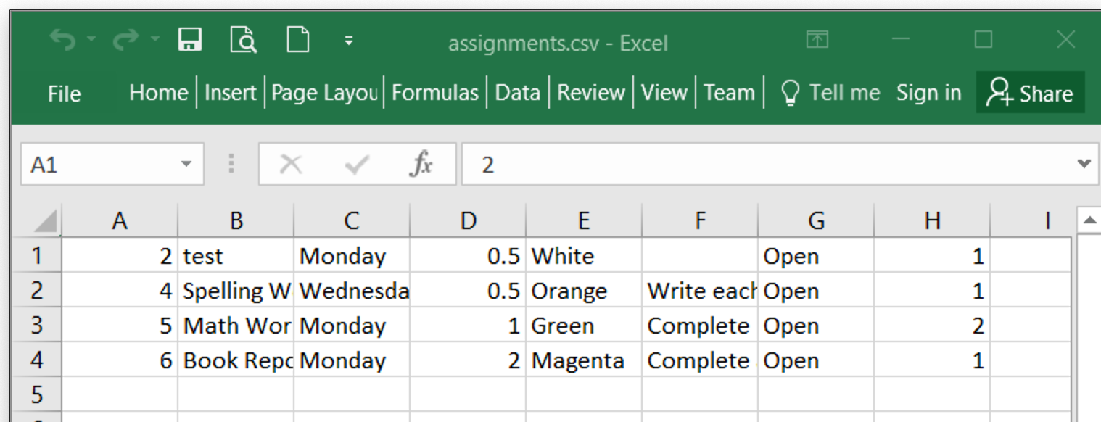

Figure 25: Successfully modified assignments file

# Delete Assignment

1. After successfully logging in and adding assignments, selected Assignments, Delete Assignment menu option.
2. Selected assignment to delete, in this case an assignment named “test”.

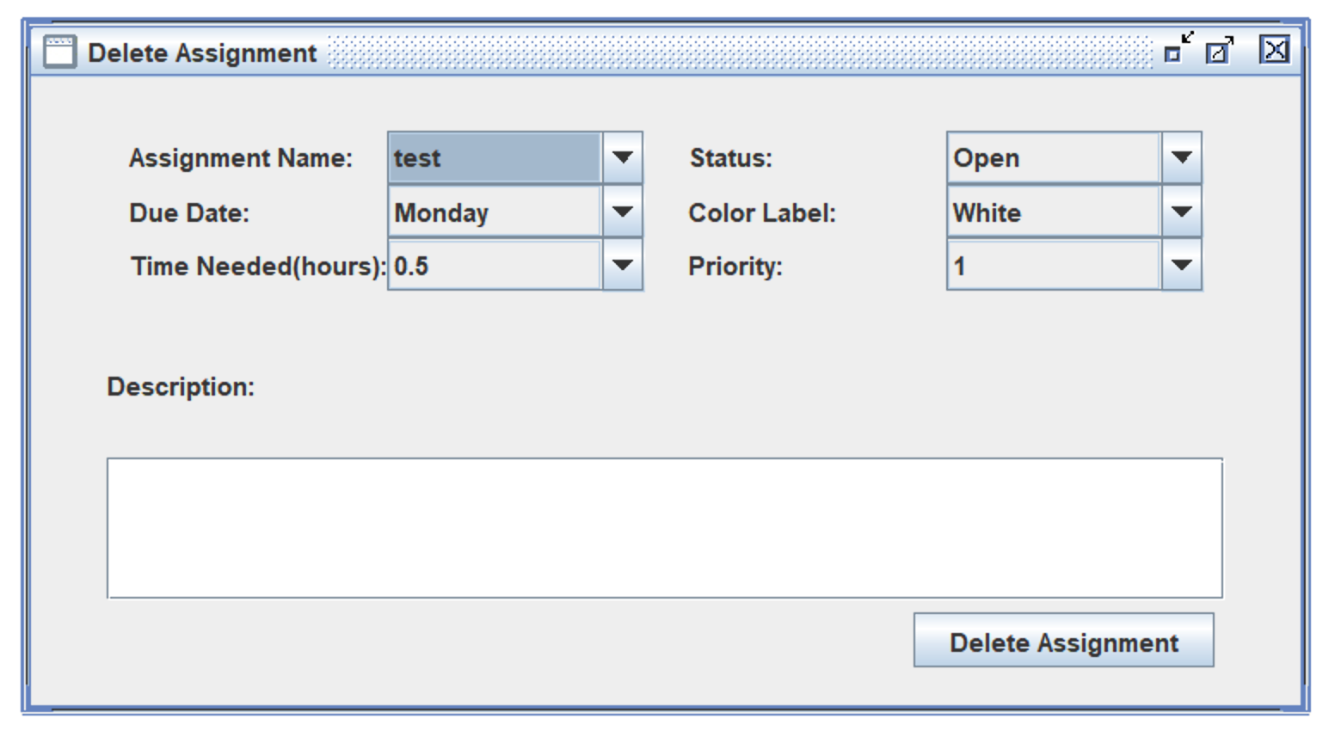

Figure 26: Delete assignment screen

1. Clicked the Delete Assignment button and received the message below asking for confirmation.

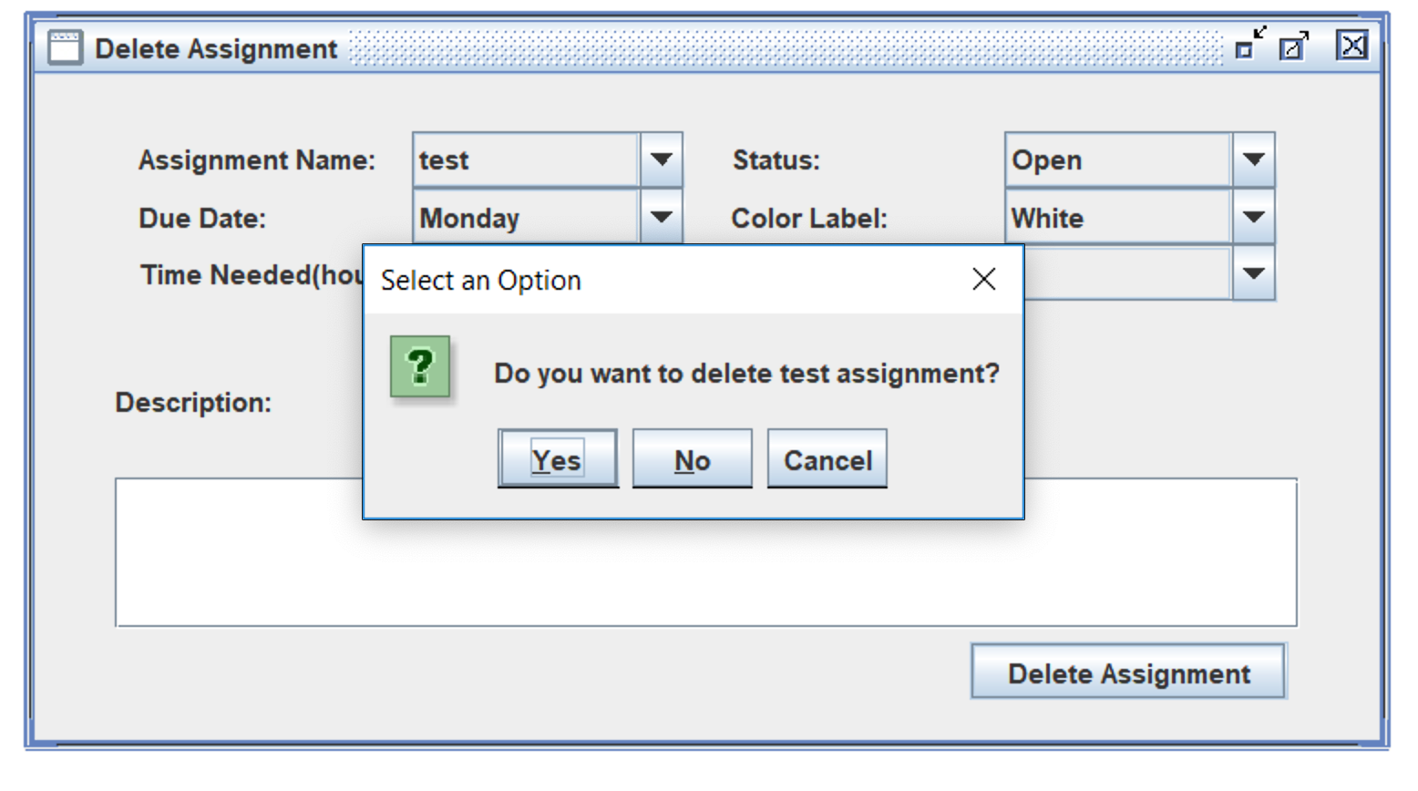

Figure 27: Confirmation of delete

1. Click No and was returned to the Assignment screen.
2. Clicked Yes and received the message below.

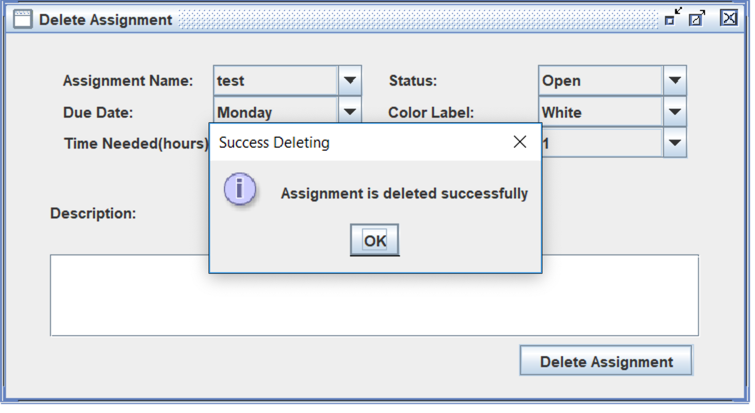

Figure 28: Successful deletion of assignment

1. The assignment file was modified accordingly.

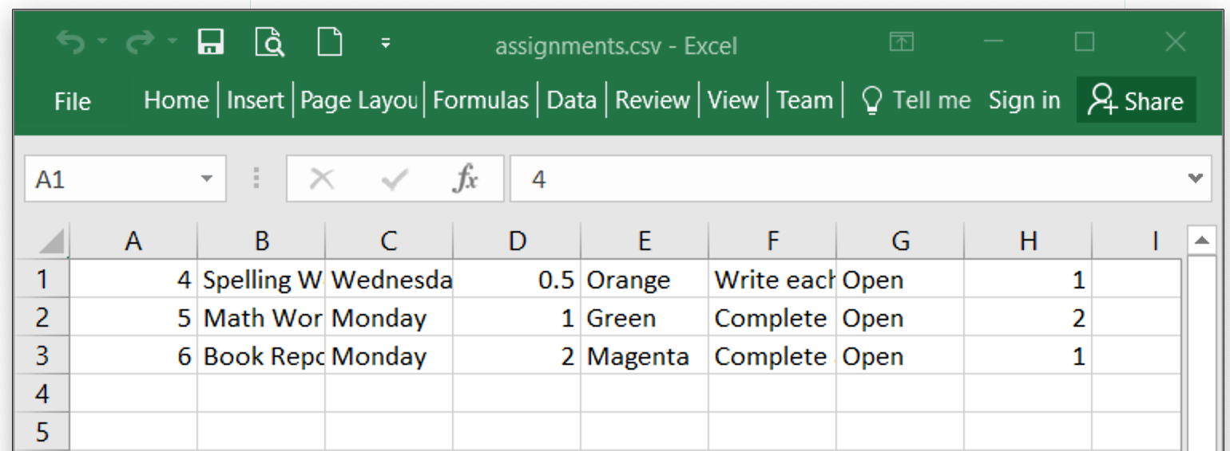

Figure 29: Assignment file modified after assignment has been deleted

# Notification

Figures 30 through 34 show that the system automatically notifies the user 30 minutes,15 minutes, 10 minutes & 5 minutes before the start of a particular assignment/task. Once the assignment time is 0 minute, the status of the assignment will change automatically to "In Progress".

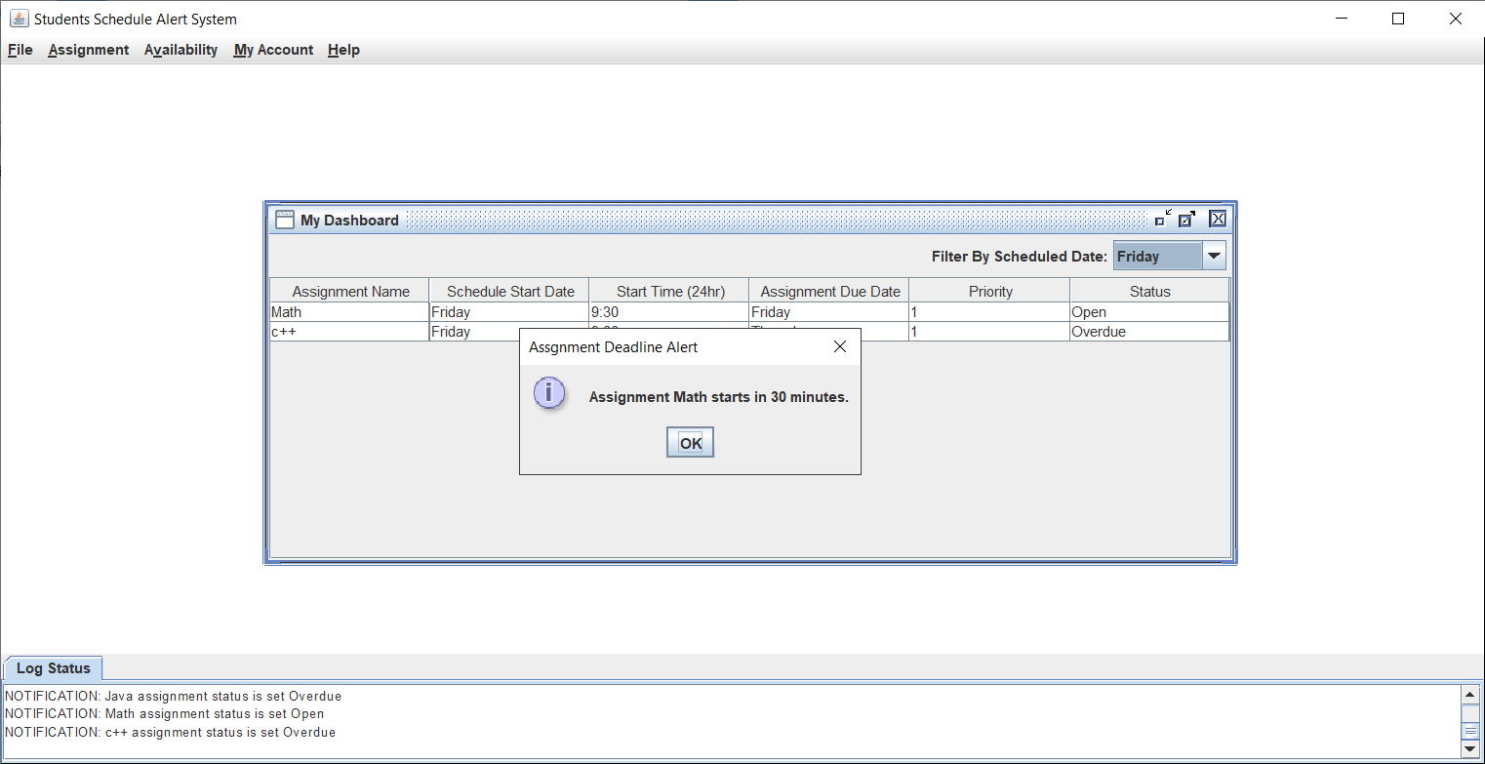

Figure 30: 30 minute assignment alert

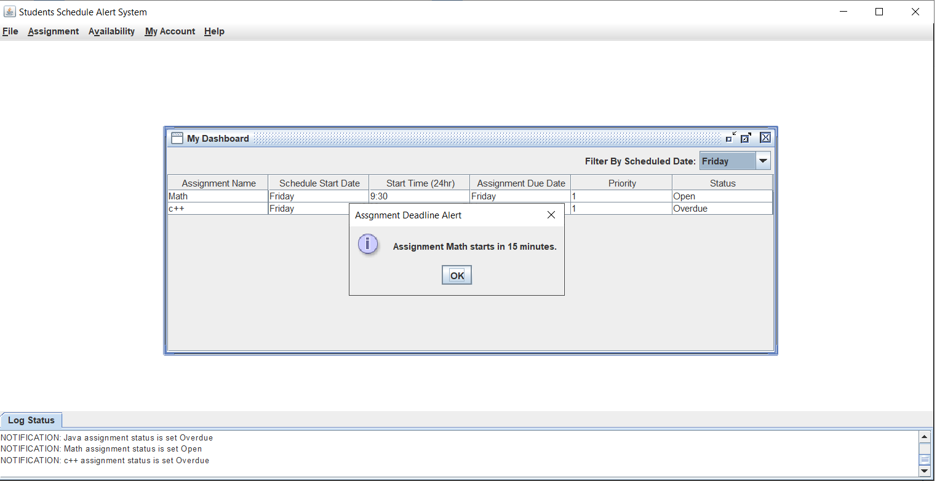

Figure 31: 15 minute assignment alert

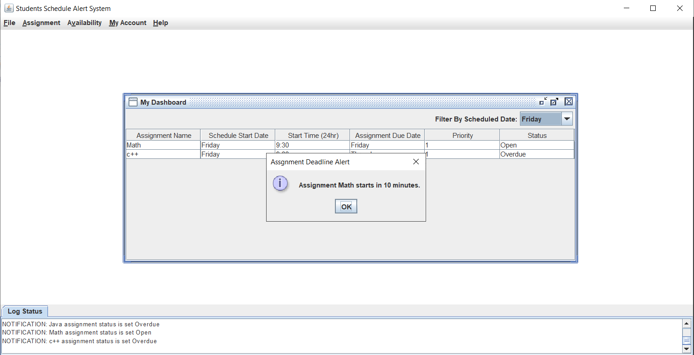

Figure 32: 10 minute assignment alert

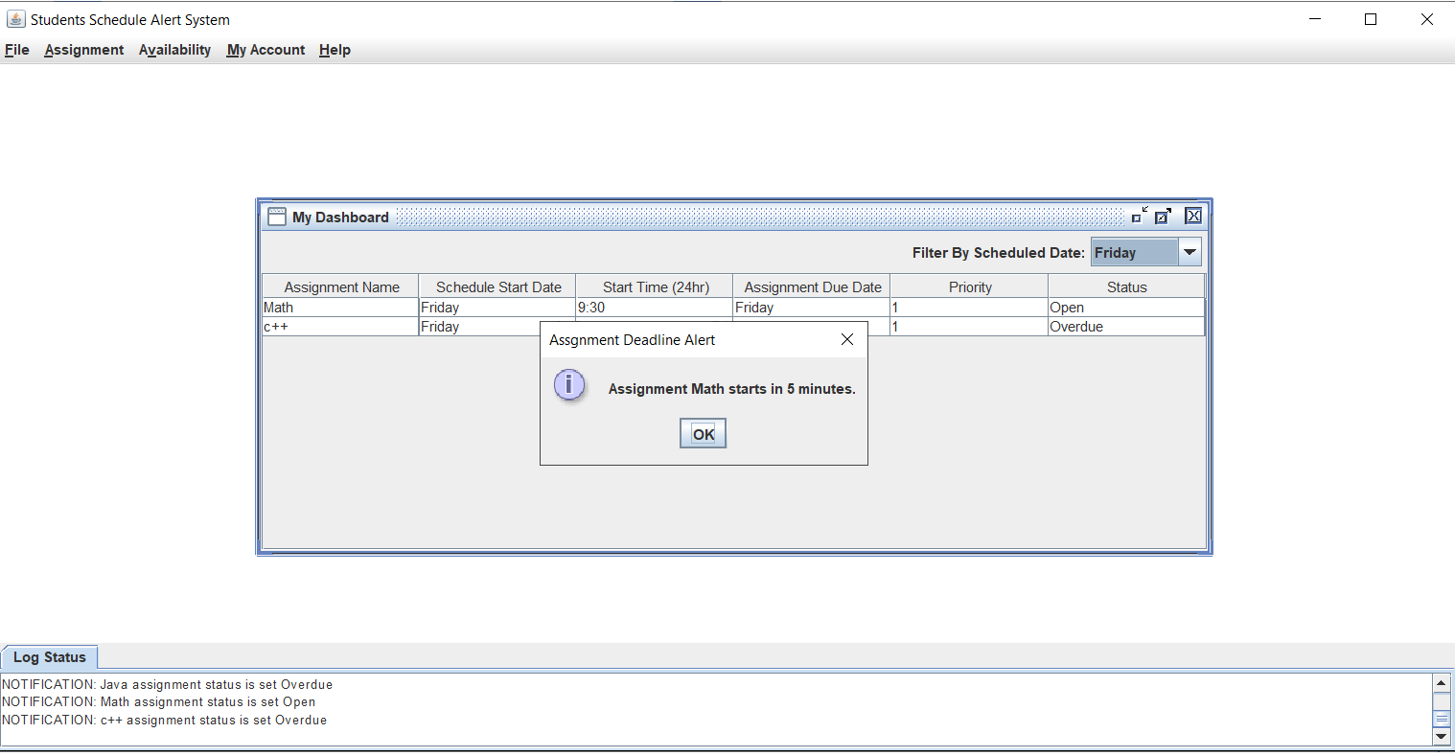

Figure 33: 5 minute assignment alert

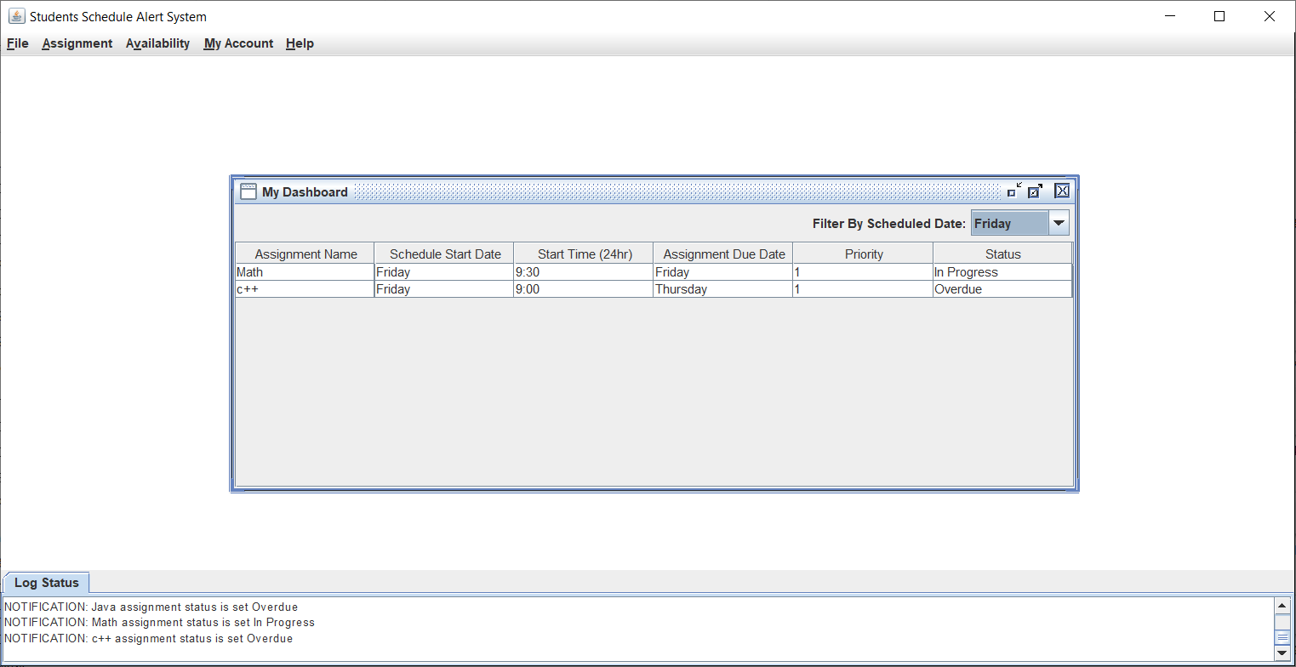

Figure 34: 0 minute when assignment changes to In Progress

# Overdue Notifications

Figure 35 shows that once the Assignment is overdue, the status will change and the Dashboard and Overdue Assignment page will show the new status.

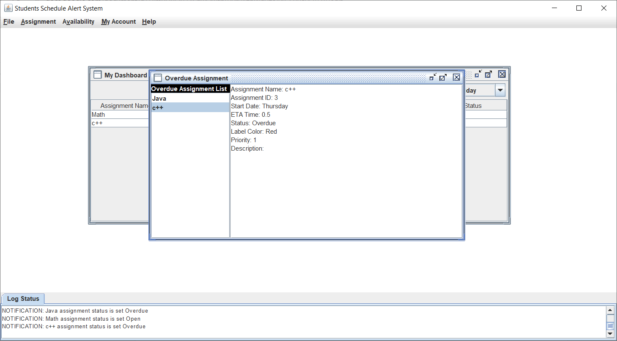

Figure 35: Overdue Assignment

# View/Edit Account

1. After successfully logging in, selected My Account, Edit/View Account. Account information is displayed as shown below.

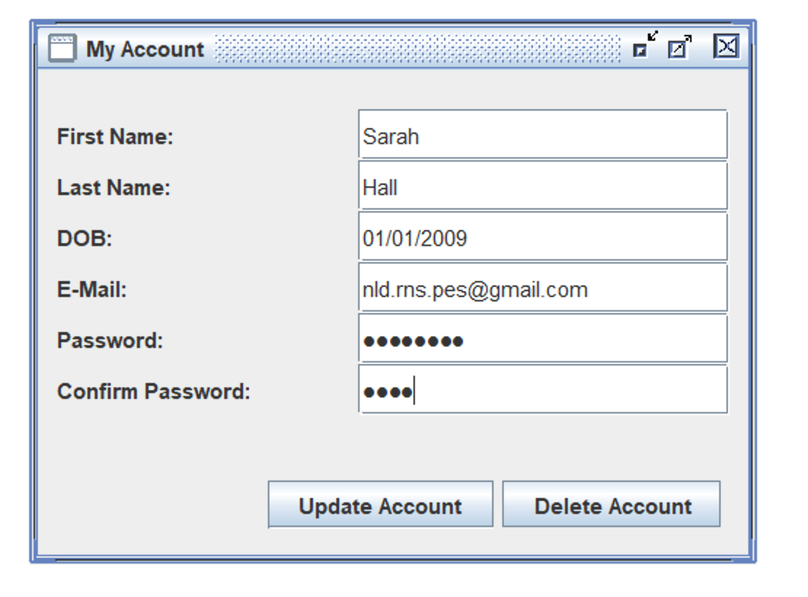

Figure 36: My Account screen

1. Modified last name and entered incorrect password confirmation. Received the message below.

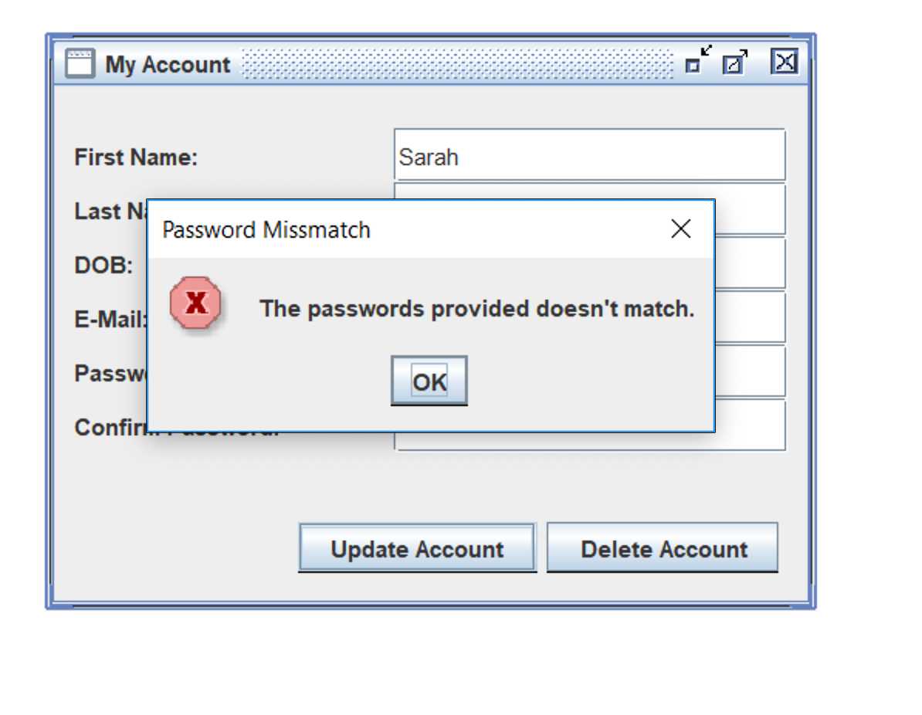

Figure 37: Incorrect password when trying to modify information

1. Entered the correct password confirmation and received the message below.

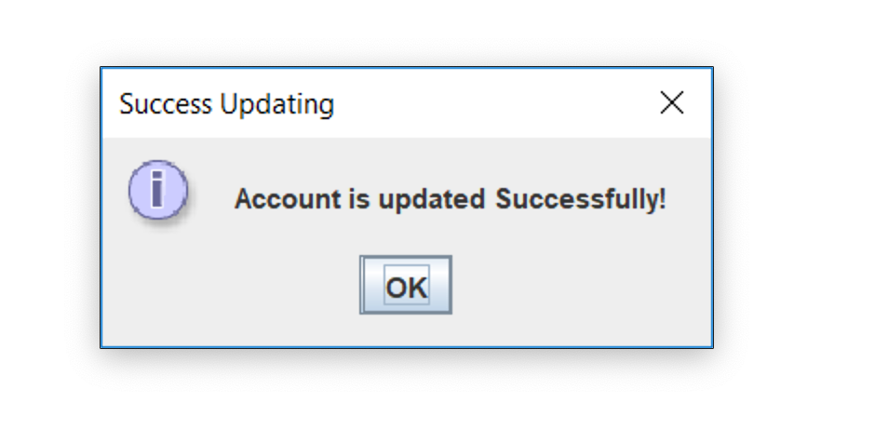

Figure 38: Account information successfully updated.

1. The user file was successfully updated.

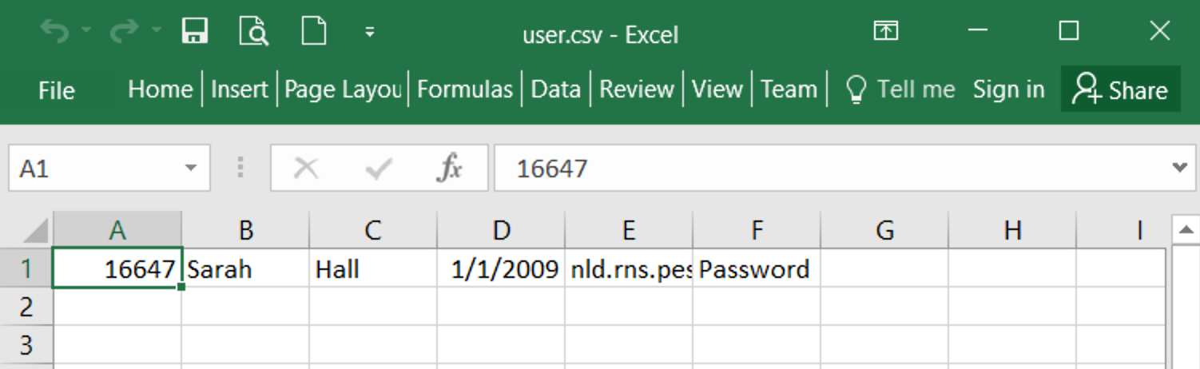

Figure 39: User file modified accordingly

# Admin User Feature

1. Logged in using the provided admin username and password. Selected My Account, Edit/View Account. The screen below displays.

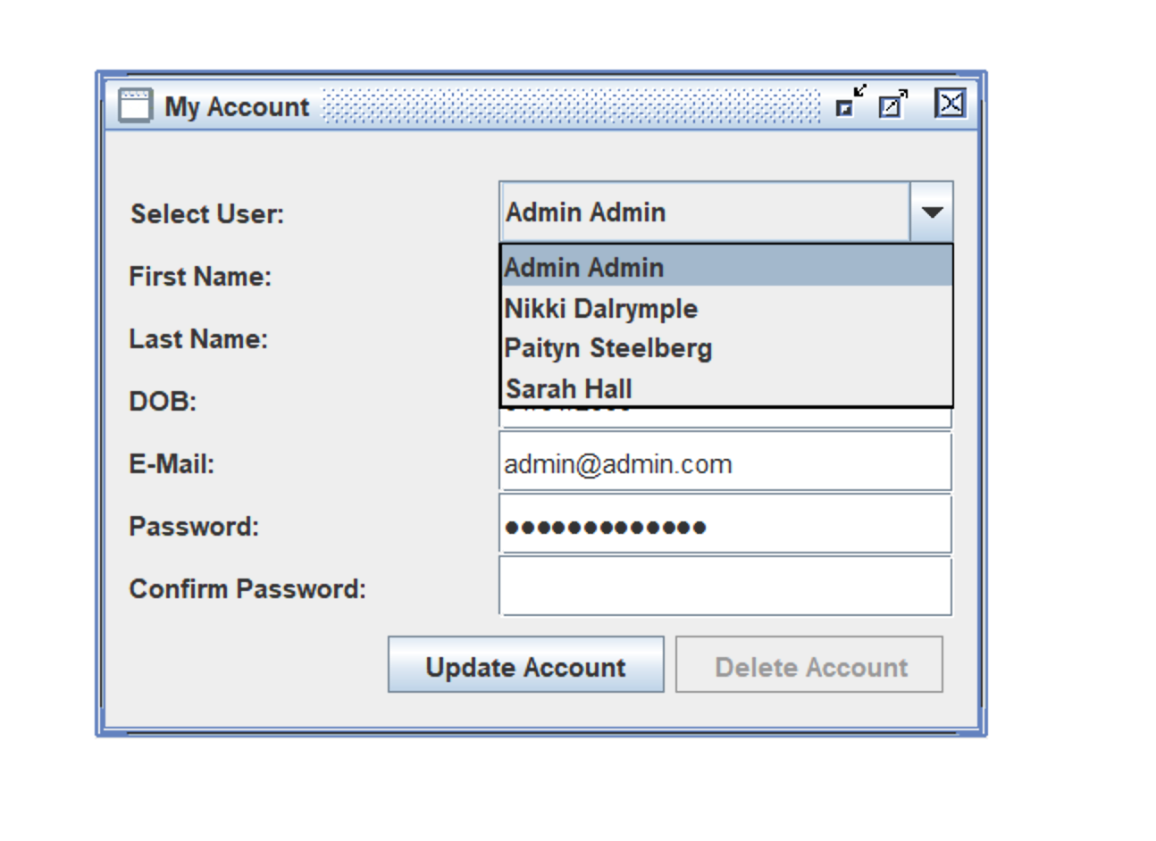

Figure 40: Selecting a user to modify as an admin

1. Selected a user to modify and changed their password. Clicked the Update Account button and received a success message.

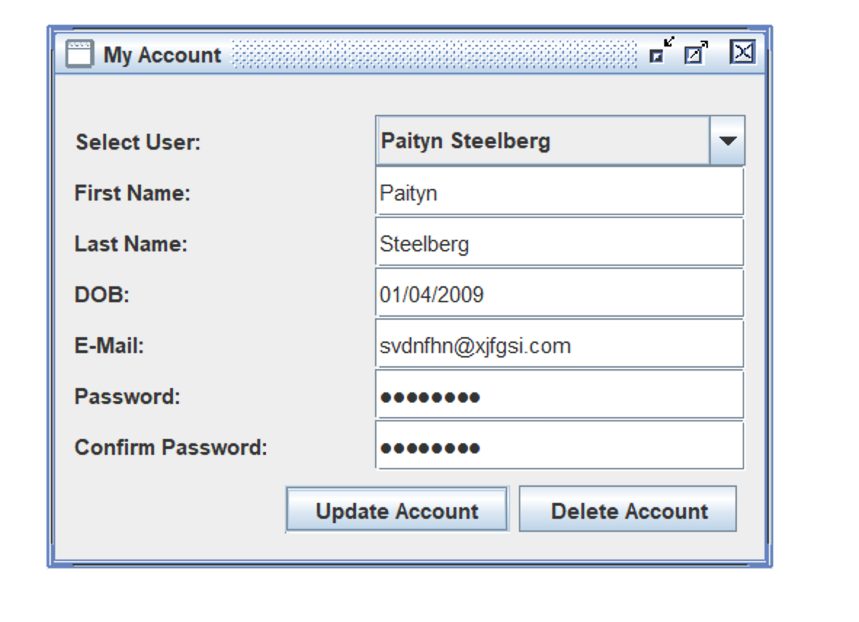

Figure 41: Updating users password as an admin

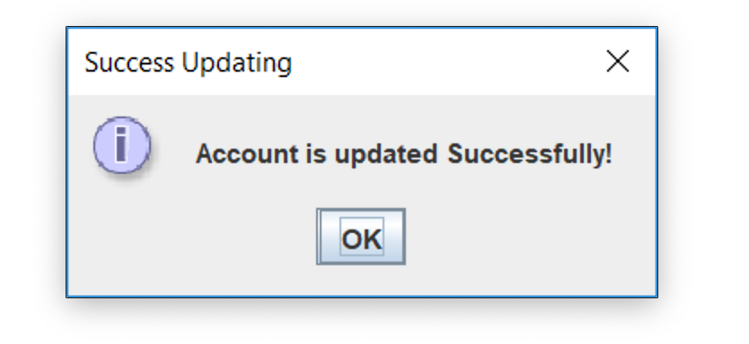

Figure 42: Account successfully updated

1. The user file was successfully updated for the selected user.

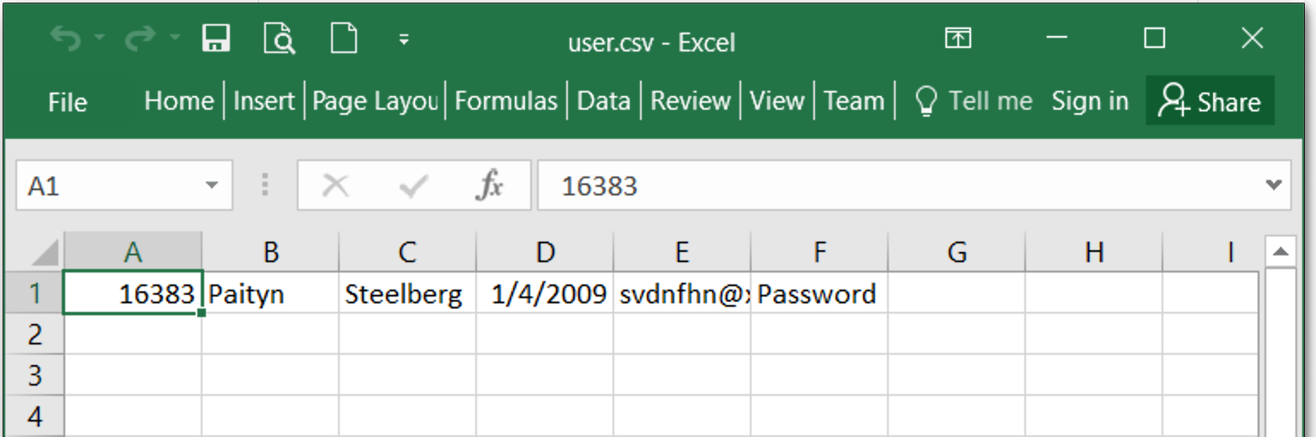

Figure 43: User file successfully modified

1. Selected My Account, Edit/View Account and selected an account to delete. Clicked the Delete Account button.

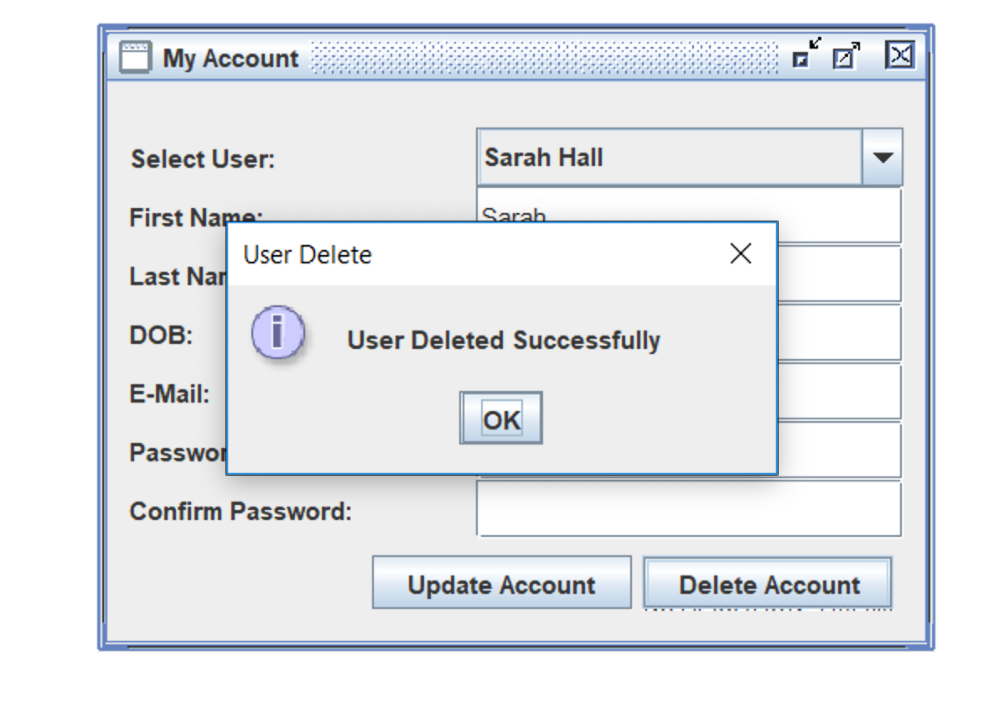

Figure 44: User successfully delete

1. The profile was successfully deleted.

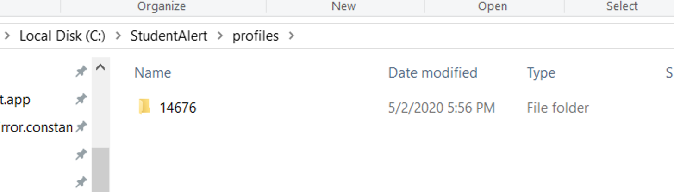

Figure 45: profile successfully deleted

# Help

Selected Help, User Guide and the user guide is displayed.

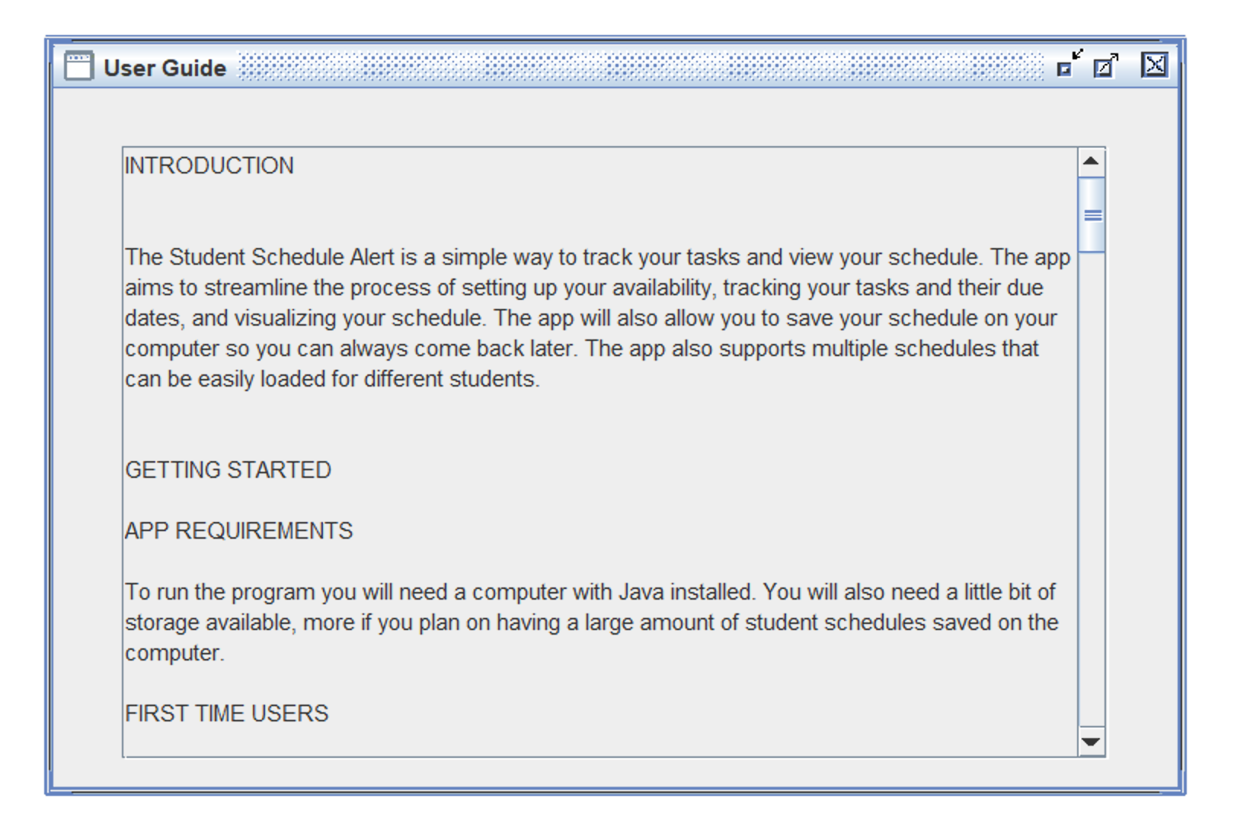

Figure 46: User guide display

# Testing Completion Approval

Testing completed on May 9, 2020.

|  |  |
| --- | --- |
| **Team Member** | **Approval/Date** |
| Nikki Dalrymple | NLD 05/09/2020 |
| Fetya Muzeyn | FM 05/09/2020 |
| Antonio Ramirez | AER 05/10/2020 |